**NAME: P V AVI KISHORE**

**REG.NO.: 192111220**

**CODE: CSA1366**

**EXPERIMENT: 9**

**AIM:** To design Turing machine to perform string comparison

W= aba aba

**PROCEDURE:**

1. Select TEN states and consider one as initial and another as final state.
2. Join the states using edges with directioons
3. Select the edges as INPUT and OUTPUT as a or b or c.
4. Give the input and start the simulation.

**DESIGN AND OUTPUT:**

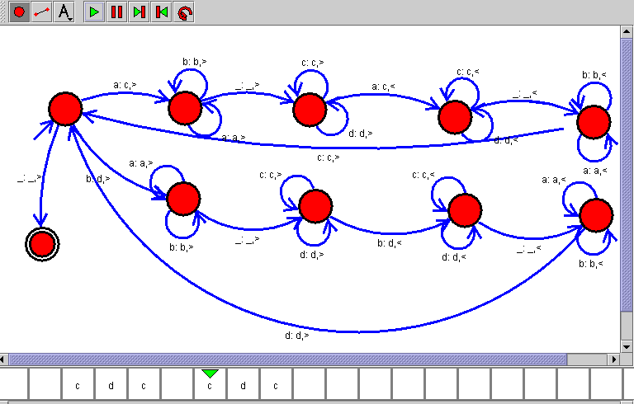

**RESULT:**

Therefore the designing of turing machine for the given input has been successfully created and stimulated.